Friday 5^{h} March 2021
Can I describe what lives in a rainforest habitat?
✍ How would you describe a rainforest?
Rainforests are_____________________________________________________
_________________________________________________________________
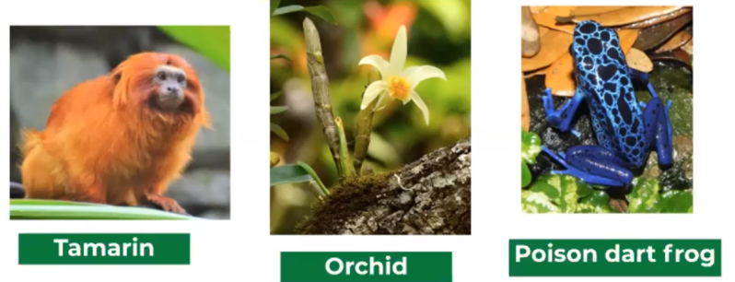
Picture
_______________________________________________________
_______________________________________________________
_______________________________________________________
_______________________________________________________
_______________________________________________________
_______________________________________________________
_______________________________________________________
_______________________________________________________
_______________________________________________________
_______________________________________________________
_______________________________________________________
_______________________________________________________
_______________________________________________________
_______________________________________________________
_______________________________________________________
_______________________________________________________
_______________________________________________________
_______________________________________________________

